import numpy as np

import pandas as pd

import sklearn

from sklearn.model_selection import train_test_split

from sklearn.ensemble import RandomForestClassifier

from sklearn.metrics import accuracy_score

from sklearn.datasets import load_iris

import sklearn.metrics as metrics

**01 Use the iris dataset**

from sklearn import datasets

iris = datasets.load_iris()

import pandas as pd

data=pd.DataFrame({

    'sepal length':iris.data[:,0],

    'sepal width':iris.data[:,1],

    'petal length':iris.data[:,2],

    'petal width':iris.data[:,3],

    'species':iris.target

})

data.head()

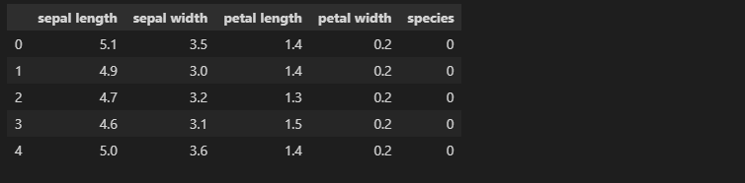

from sklearn.model_selection import train_test_split

X= data[['sepal length', 'sepal width', 'petal length', 'petal width']]  # Features

y= data['species']  # Labels

X_train, X_test, y_train, y_test = train_test_split(X, y, test_size=0.3)

**02 Using SVM and Random Forest**

from sklearn.ensemble import RandomForestClassifier

from sklearn.svm import SVC

svm_clf=SVC()

rf_clf=RandomForestClassifier(n_estimators=100)

svm_clf.fit(X_train,y_train)

rf_clf.fit(X_train,y_train)

y_pred_svm=svm_clf.predict(X_test)

y_pred_rf=rf_clf.predict(X_test)

from sklearn import metrics

print("Accuracy of SVM:",metrics.accuracy_score(y_test, y_pred_svm))

print("Accuracy of Random Forest:",metrics.accuracy_score(y_test, y_pred_rf))



**03 Using grid search with cross-validation to select best parameters**

from sklearn.model_selection import GridSearchCV

from sklearn.model_selection import cross_validate

from sklearn.metrics import recall_score

# Create a dictionary called param_grid and fill out some parameters for C and Gamma

param_grid = {'C':[0.1,1,10,100], 'gamma':[1,0.1,0.01,0.001]}

grid = GridSearchCV(SVC(), param_grid, refit = True, verbose=3)

scoring = ['precision_macro', 'recall_macro']

scores = cross_validate(grid, X, y, scoring=scoring)

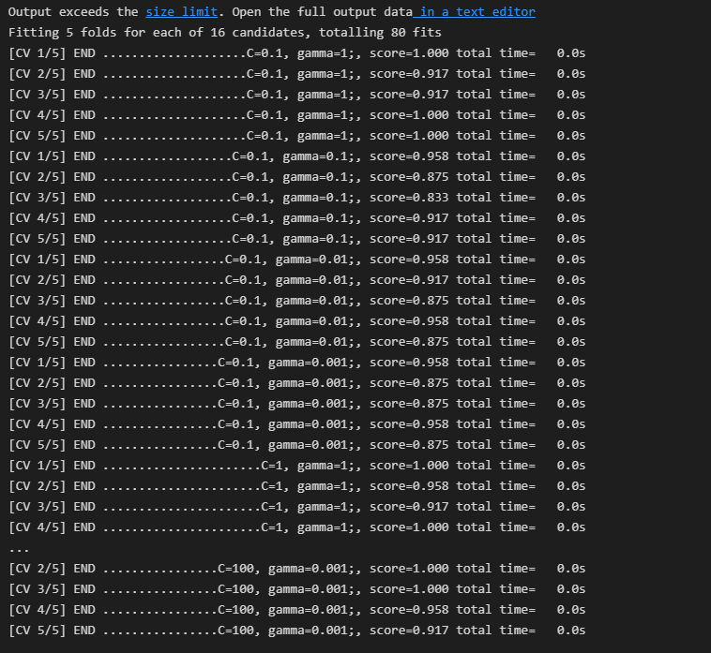

sorted(scores.keys())



scores['test_recall_macro']



pred_grid = grid.predict(X_test)

print("Accuracy of Grid Search:",metrics.accuracy_score(y_test, pred_grid))



**04 Using two matrix (Confusion_matrix and F1-score)**

from sklearn.metrics import confusion_matrix

from sklearn.metrics import f1_score

# for SVM

print(confusion_matrix(y_test, y_pred_svm))

print(f1_score(y_test, y_pred_svm, average=None))

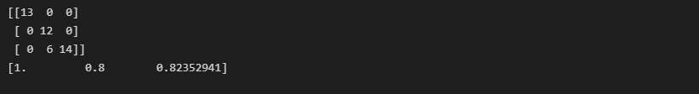

# for Random Forest

print(confusion_matrix(y_test, y_pred_rf))

print(f1_score(y_test, y_pred_rf, average=None))

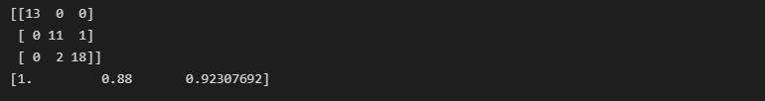

# for Grid Search

print(confusion_matrix(y_test, pred_grid))

print(f1_score(y_test, pred_grid, average=None))

